WhatsApp Bot For Disease Detection

Rajeswar Sharma  
*Department of CSE*   
*Chandigarh University*Mohali, India  
19BCS6051@cuchd.in

Aman Sharma  
*Department of CSE*  
*Chandigarh University*Mohali, Indi  
19BCS6043@cuchd.in

Vishal Choudhary  
*Department of CSE*  
*Chandigarh University*Mohali, India  
19BCS6073@cuchd.in

Kritesh Sharma  
*Department of CSE*  
*Chandigarh University*Mohali, India  
19BCS6057@cuchd.in

Puranjay Kwatra  
*Department of CSE*  
*Chandigarh University*Mohali, India  
19BCS6061@cuchd.in

Dr. Deepak Mehta  
*Department of CSE*  
*Chandigarh University*Mohali, India  
deepak@cumail.in

*Abstract*— Cancer is a fatal illness often caused by genetic disorder aggregation and a variety of pathological changes. Cancerous cells are abnormal areas often growing in any part of the human body that is life-threatening. Cancer also known as a tumor must be quickly and correctly detected in the initial stage to identify what might be beneficial for its cure. Even though modality has different considerations, such as complicated history, improper diagnostics, and treatment that are the main causes of deaths. The aim of the research is to analyze, review, categorize and address the current developments in human body cancer detection using machine learning techniques for breast, brain, lung, liver, and skin cancer leukemia. This study highlights how machine learning using supervised, unsupervised and deep learning methods is used in the cancer diagnosis and treatment process. Several modern methods reference the same cluster and compare results on a benchmark dataset in terms of accuracy, sensitivity, specificity, and false-positive rates. Finally, issues for future workability are also highlighted..

Keywords—***Cancer***, Life expectancy, Health systems, Image analysis, Machine learning

# Introduction

In the past 10-year period, from 2008 to 2018, the annual number of melanoma cases has increased by 53%, partly due to increased UV exposure . Although melanoma is one of the most lethal types of skin cancer, a fast diagnosis can lead to a very high chance of survival. The first step in the diagnosis of a malignant lesion by a dermatologist is visual examination of the suspicious skin area. A correct diagnosis is important because of the similarities of some lesion types; moreover, the diagnostic accuracy correlates strongly with the professional experience of the physician. Without additional technical support, dermatologists have a 65%-80% accuracy rate in melanoma diagnosis . In suspicious cases, the visual inspection is supplemented with dermatoscopic images taken with a special high-resolution and magnifying camera. During the recording, the lighting is controlled and a filter is used to reduce reflections on the skin, thereby making deeper skin layers visible. With this technical support, the accuracy of skin lesion diagnosis can be increased by a further 49%. The combination of visual inspection and dermatoscopic images ultimately results in an absolute melanoma detection accuracy of 75%- 84% by dermatologists.

This article provides advanced assistance to dermatologists through deep learning. The essence of the approach is that computers are trained to analyze images of skin cancer to identify problems. The novelty of the presentation lies in the fact that computer models can be developed without programming knowledge. The average diagnostic accuracy using this model is about 98.89%, with the highest being 100%. The mechanical diagnosis presented here overcomes the problems of delay, accuracy, and shortage of dermatologists in public health. According to studies, there are many scientific papers in the field of skin cancer diagnosis and image classification. A detailed review of these methods is available in the work. Each of these articles used the latest technology available at the time and claimed performance improvements. Popular methods used for image classification range from application of decision tree algorithms, Bayesian classifiers supporting vector machines, to various approaches based on artificial intelligence. However, what all these articles have in common is that they are presented as the work of experts in the fields of computer and software development. Building these diagnostic models requires a basic level of programming knowledge in computer languages such as Java, R, and Python. This article reviews how to develop a deep learning-based image classification model for skin cancer detection without prior programming knowledge.

# Related works

A systematic and well-planned search is critical to gathering useful information from the data you are looking for in the right domain. At this stage, an exhaustive search was performed to extract meaningful and relevant information from the vast amount of data. We have created an automated search engine that filters the desired domain data from any source. Reference lists of research papers, case studies, American Cancer Society reports, and related publications have been reviewed in detail. Websites with information about skin cancer, risks of skin cancer, causes of skin cancer, and NN methods to detect skin cancer have been scrutinized. The following parameters were retrieved to extract the relevant data we wanted.

Identification of search keywords/search terms according to research question.

Words related to search keywords.

Formulating search strings using logical operators between search terms.

Keywords related to deep learning techniques for diagnosing skin cancer were selected. Since then, searches have expanded to synonyms for these keywords.

As mentioned above, there are several papers that suggest image processing-based skin disease diagnosis. Various methods mentioned in the literature were reviewed. [1] Arifin, S., Kibriya, Firoza, A. Amini, and Jan H., el. In "Diagnosis of Diseases by Dermatologists Using Skin Color Imaging", we proposed a two-step method for disease detection that uses color texture-based identification and classification to determine disease names. The accuracy of the first step is 95.99% and the accuracy of the second step is 94.016%. [2] Email Nawal Soliman and A.L.Kolifi Al-Enezi. "Skin disease diagnosis method using image processing and machine learning" proposes an early diagnosis method for image processing based on a convolutional neural network, extracting features and then identifying features using color. [3] Praveen S. Ambad and A. S. Shirsat at el. “An image analysis System to detect skin diseases” has proposed a system for early identification of skin problem using statistical analysis and ad boost classifier. Their research mainly focused on early identification of skin cancer symptoms based on statistical analysis with correlation algorithms. In [4] Lisheng Wei, Quan Gan, and Tao ji at el. "Methods for Recognizing Skin Diseases Based on Color and Texture Features of Images" proposed a model based on extracting features of images using color texture and identifying diseases using segmentation and SVM on them. in [5]PYasir, M.S.I. Nibir and N. Ahmed in email. "Skin disease diagnosis system in economically unstable developing countries" proposed a disease diagnosis system that can be implemented not only on a computer but also on a mobile device using a desktop application based on computer vision technology. [6] R Sumithra, M Suhilb and DS guruc at el. "Classification and Classification of Skin Lesions for Disease Diagnosis" We proposed a model to classify and classify skin diseases using SVM and KNN algorithms. [7] Rahat Yasser, Md. Ashikur Rahman and Nova Ahmed emails. “Dermatological Disease detection using image processing and artificial neural network” has used various kind of different image processing algorithms for feature extraction and feed forwarding using artificial neural network for training and testing the model. The system works on two parts, in the first part the feature extraction has been taken place based upon the color texture and in the second stage, the classifier identifies the possible disease. In [8] Nidhai k, Al Abbadi, Nizzar Saadi at el., “Psoriasis detection using skin color and texture features” has proposed a model for identification of psoriasis using color feature extraction and classification of the skin image. In [9] Kumar, V., Kumar S., & Saboo, V. at el, “Dermatological disease detection using Image Processing and machine learning” has proposed a model which uses computer vision and machine learning. It extracts features from images and applies algorithms to detect six diseases with up to 95% accuracy. [10] Pollap D. et al. "Intelligent Skin Disease Monitoring" proposed an image clustering method using search for classification. They used the SIFT method to detect key points in the image.

[12] in Abbadi et al. The section "Detecting psoriasis using skin color and texture characteristics" describes the color feature extraction method and texture extraction method for detecting psoriasis on the skin. color characteristics are extracted using a proprietary mathematical formula for RGB colors. Also rich in texture features is the Journal of Physics: Conference Series. It was extracted using various components such as entropy, energy, contract, and image uniformity. After that NN algorithm are used to find the psoriasis on the skin. In [13] Megha D. Tijare et al. “Detecting skin disease by accurate skin segmentation using various color spaces” has presented a servey paper on how various skin segmentation techniques are helping in detecting of the skin disease. Also mentioned the various steps which are used alongside the detection of these diseases. In [14] Ekta Singhal et al. Skin cancer detection using Artificial Neural Network has used Segmentation, Feature Extraction and Classification technique to get the result. Segmentation is done using Thresholding, then features are extracted using 2D wavelet decomposition. And then classification is done using back propagation neural network and radial basic neural network. In [15] Manish Kumar and Rajiv Kumar et al. Intelligent Skin Disease Diagnosis System proposed formulas for image segmentation and subsequent feature extraction from images. For function Extract, various parameters such as mean, variance, energy and entropy are calculated from the image ( ). In [16] Shashi Rekha at al. The digital dermatological skin disease detection model using image processing proposed a model for detecting 6 skin diseases and skin conditions based on feature extraction and image classification methods. [17], VR.R. Balaji, etc.Etc. Skin disease detection and segmentation using dynamic graph slicing algorithms and classification using naive Bayes classifier, graph slicing algorithm is used for image processing of skin images, and naive Bayes algorithm is used as classification algorithm. [18], Nawal Soliman et. Etc. For the skin disease diagnosis method using image processing and machine learning, the image processing method, CNN, and SVM algorithm were used as the machine learning algorithm . [19] Sumitra d. different. Segmentation and classification of skin lesions for disease diagnosis proposed a disease detection method using a combination of SVM and KNN algorithms. A segmentation and classification methodology was used to obtain an Fmeasure accuracy of 61%. [20] Menzis et al. The frequency and morphological characteristics of invasive melanomas without specific surface microscopic features were proposed to be a model based on the SVM classifier to identify melanomas. Using color and texture feature extraction, a sensitivity result of 96% and a specificity result of 75% were obtained. The following conclusions can be drawn from the literature review. • Support vector machines are primarily used to detect and predict skin diseases. • SVM accuracy is around 8090% depending on the data set used. • The skin disease data set was taken from the UCI Machine Repository as it contains thousands of images for different skin conditions. • Analyze results using parameters such as accuracy, F-score, specificity, and entropy.

# Literature review

## A. ***Brain Tumor***

A tumor in the brain is an abnormal cell collection that has four degrees. Grade 1 and 2 brain tumors are tumors with a tendency to grow slowly and tumors with a grade 3 and 4 are cancerous (malignant) and grow quicker and harder to treat. There are some basic steps for tumor detection, the preprocessing phase is carried out to remove noise and nonbrain tissues from the input image to enhance accuracy [65]. The brain surface extractor (BSE) techniques are employed to remove nonbrain organs. The fast nonlocal mean (FNLM), partial differential diffusion filter (PDDF), and Wiener filter are employed to suppress noise, and contrast stretching is utilized for contrast enhancement. The most popular brain tumor segmentation methods are fuzzy C-means, k-means clustering, and Otsu threshold methods. Similarly, the UNet architecture is also one of the popular CNN architectures used for brain tumor segmentation. After the segmentation process, the segmented image is converted into a mathematical description by extracting the manually generated features. Currently, we use a more reliable method to extract features and then use them for classification. Well-known feature extraction techniques include Histogram Direction Gradient (HOG), Heirloom Wavelet Transform (GWT), Local Binary Pattern (LBP), and shape-based features. In addition, various feature selection and reduction methods such as genetic algorithms (GA) and principal component analysis (PCA) are used for optimal feature selection. The current CNN architecture is also considered a powerful method to detect brain tumors.an enhancement of RNN wherein the recurrence conditions are changed as to how the hidden states are propagated. The cell state can be considered as a long-term memory that retains a part of the information in earlier states using a combination of partial "forgetting" and "increment" operations on the previous cell states. The advantage of this approach is that the network can model long-range dependencies in a sequence extended over a large number of tokens. The updation of these cell states over time creates greater persistence in information storage. This persistence mitigates the problem of exploding and vanishing gradients.

Each cell in LSTM are computed as follows:

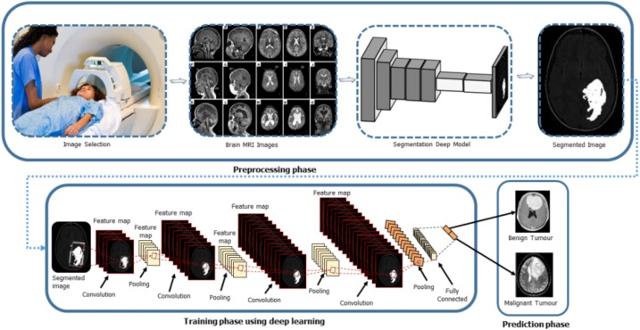

*B. Lung Cancer*

Lung cancer is one of the most common causes of death in the world. If the tumor is a small, diffuse tumor, a variety of surgical, percutaneous, and surgical treatments will benefit many patients. Unfortunately, in 75% of lung cancer cases, the diagnosis of advanced clinical disease, nodular progression and/or metastasis is discovered later, as there are rarely asymptomatic cases in the early stages of the disease. According to an Australian study, the overall survival rate for patients diagnosed with lung cancer is 15% . Several researchers have reported on the detection and classification of pulmonary nodules using the LIDC/IDRI database. The database consists of over 240,000 nodule images. Machine learning can help early diagnosis and evaluation of pulmonary nodules by processing CT images generated by artificial intelligence. These systems, called decision support systems, examine images through preprocessing, segmentation, feature extraction, and classification processes. MultiConvolution Neural Networks (MCNN) are used to capture node heterogeneity by extracting features from interleaved layers. Pulmonary nodule screening and annotation is used to evaluate the proposed LIDCIDRI method. In this method, three CNNs are used in the MCNN model, and parallel sections of knots of different sizes are collected as inputs. The LIDC database was used and the accuracy of the segmentation method is 97%. Setio et al. proposed a method to detect pulmonary nodules and trained a model using a convolution multiview network. Three algorithms combine to accurately detect all suspicious nodules by detecting candidate nodules: large dura, subsolid and solid. The proposed system was trained and validated on the publicly available LIDCIDRI dataset. The sensitivity level achieved by the research work is 85.4% at 1 and 90°.

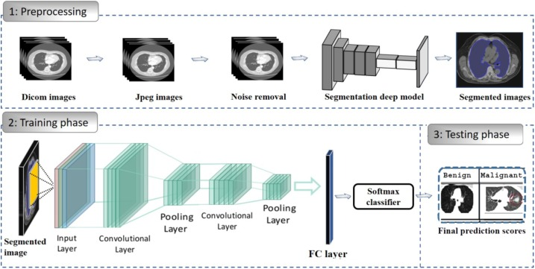

## C. Skin Cancer

The machine assisted systems employing dermoscopic images have been started form the last few decades to help the dermatologists clinical decision and to detect highly suspicious cases. The intelligent systems could also be used as an extra tool by nonexperienced clinicians to achieve an initial assessment and to increase the patient follow up process [91,136]. Roughly, such systems are divided into two major classes concerning meaningful feature extraction from dermoscopic images In which one class used medical procedure of diagnosis and extract automatically the same medical features i.e. symmetry, several colors, atypical differential structures. Additionally, another class is based on machine learning to recognize statistical patterns and applied to image features i.e. texture and color features [92]. In most of the work, the focus is on the development of machine learning techniques with advanced features extraction, such ABCD rule, a 3point checklist. Thus, DCNN has made significant strides in medical imaging thanks to its ability to generate features directly from images. rice. 4 shows a manually fabricated CNN feature extraction structure.

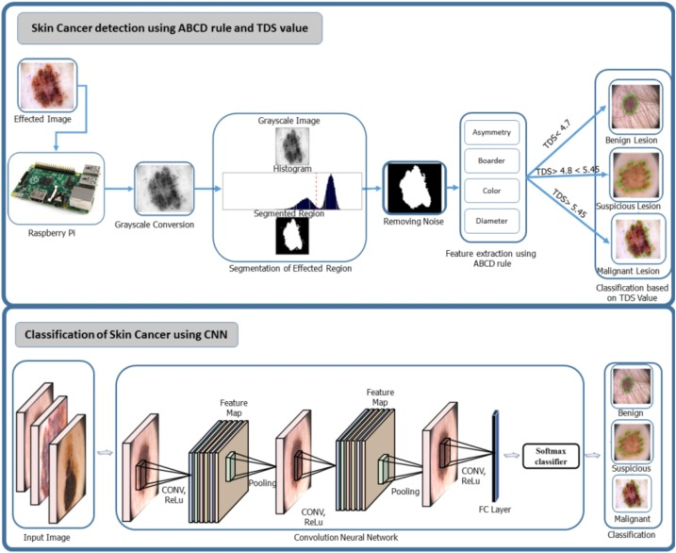

*D. ALL(Acute Lymphoblastic Leukemia)*

Acute lymphocytic leukemia (ALL) is a type of cancer of the blood and bone marrow. Literature reveals different machineassisted Acute Lymphoblastic Leukemia (ALL) classification techniques in health applications. White Blood Cells (WBC) segmentation involves separating the cell from its background, often through the identification of the cell's cytoplasm and nucleus . This is readily achieved through image processing functions available in medical software. Converting the image to a different color space, contrast stretching, thresholding, cauterization, watershedding, and morphological filtering are some steps mentioned in the literature. These steps can mask the original color image by generating a binary image of the white component of the leukocyte . Segmentation of leukocytes in many studies has used morphological observations in grayscale microscopy images. Because the color of leukocytes is darker than that of other blood components, contrast stretching was performed to emphasize the nuclei of leukocytes. Then, the leukocyte diameter was averaged to obtain a morphological filter. The use of this morphological filter further increased the number of leukocyte nuclei while reducing the smaller blood components. These steps produced subimages of fixed dimensions containing centrally located WBCs with high accuracy. Putzu et al. improved this strategy by inserting additional colorspace conversion and thresholding steps. Also, grouped WBCs were separated through watershed segmentation yielding 92% accuracy.

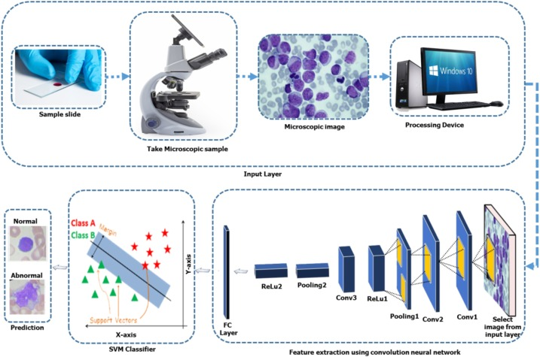

## *E. Breast Cancer*

Breast Cancer occurs in the breast cells and is the most prevalent cancer in women in the world after skin cancer. Males and females both may suffer from breast cancer, but it is much more prevalent in females . Machineassisted systems are not only the latest development in medical imaging for the initial finding of breast cancer but also enhance the diagnostic skill of radiologists. The most common tools employed for breast cancer diagnostics are mammography, tomography, Breast Ultrasound (BUS), MRI, CT scans, and even more deeply PET is advised . Typically, the breast is counted as the oversensitive organ of the human body, so only some of these procedures are advised, which depends upon the patient's condition and the tumor status. Mammography is considered a lowcost and secure procedure at an early stage of breast cancer, but it is ineffective in the dense breasts of young females. BUS procedure is considered supportive of mammograms to prevent needless biopsy. Several datasets of breast imaging are publically available which are DDSM, MIAS, WBCD, BCDR, NBIA, etc . Following image acquisition, various operations of preprocessing are performed before segmentation such as pectoral muscle removal and artifacts removal, etc. The process of segmentation is the most important step of the machineassisted system for enhancing accuracy and reducing false positives of the existence of abnormality. Many studies have recommended the GLCM method to describe texture features . Similarly, LBP is another surprising mechanism used for tissue extraction to isolate benign lesions from malignant lesions . Diagnosis of breast cancer is highly dependent on the effectiveness of the classification. Several machine learning approaches, such as neural networks, decision trees, KNN classifiers, SVMs, and ensembles, are applied to train and test functions to classify objects into malignant or benign classes . To identify biased genes, Ref. proposed a hybrid selection model. Many groups of problems are solved with decision tree classifiers and breast cancer subtype predictions using the same or fewer origin numbers with 100% accuracy. The use of machine learning methods has produced groundbreaking results in the life sciences, especially in the use of deep learning architectures, which have produced encouraging results. CNN is currently recruiting researchers to detect and classify breast tumors. There are several CNN framework projects such as AlexNet, CiFarNet, GoogLeNet, VGG16 and VGG 19.

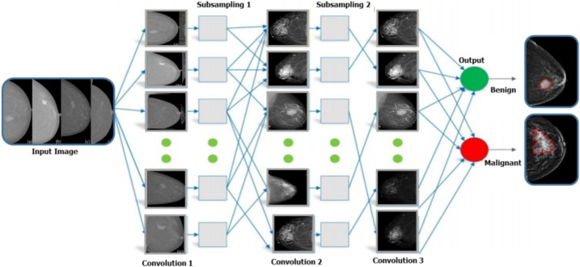

## F. Liver cancer

Most scientists have used machine learning methods to detect tumors in the liver [122]. Automated systems using multi-step CT imaging use three characteristics: shape, shape, and curve of motion. The design of CNN used multiphase MRI and obtained an integrated CNN-centric process for thinking of CT image slices [124]. Researchers compared CNN models with existing machine learning algorithms such as AdaBoost, RF, and SVM. These classifiers are designed with mean, variance, and contextual characteristics. The mean dice comparison ratio (DSC), accuracy, and warning were 80.06% ± 1.63%, 82.67% ± 1.43%, and 84.34% ± 1.61%, respectively. The findings suggest that the CNN approach outperforms other approaches and is promising for hepatic tumor segmentation. The performance and contrast of AdaBoost, RF and SVM were tested on a rather limited data set. Regions of interest (ROI) pixels are defined using a standardized rotationally invariant local binary template system in groups of nine textures. Therefore, the Spatial Cone Mapping Description Method (SCM) was introduced to describe the spatial details of visual ROI terms.

# Methodology

The proposed methodology of the research work is as follows:

− The problem is defined over a research problem that includes the target domain such as – skin disease problem which is to be worked on and listed the literature survey papers which are related to this domain.

− We searched the 28 papers from Scopus, the Web of Science platform which is related to skin disease prediction, we removed 8 papers from our review study as we feel that they were not pertaining to the quality of the research.

− Literature survey is done and we found that SVM is mostly used for classifying skin diseases using machine learning.

− Based on the recommendation of the literature review, the Support Vector Machine algorithm (SVM) is selected as a classification algorithm. We formulated the problem and research questions based on SVM.

- Apply the SVM to the skin disease dataset and present the results. A corresponding output is made.

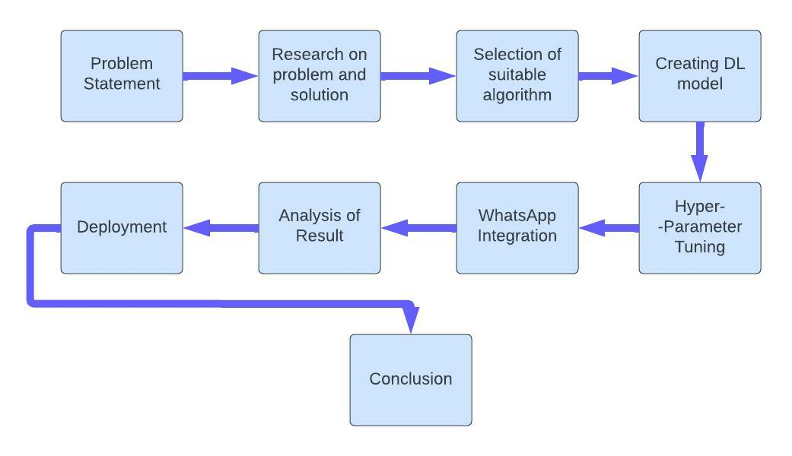

## The Dataset

Our data set consists of around 3000 images collected from several sources such as BeniSurf University Hospital, Cairo University Hospital, and various skin diseases and treatment websites that are more accurate and realistic. The data is split into two parts: a training set of and a test set. The training set data is used to train the model, and the test set is used to test whether the model performs well. The data set is then divided into different parts according to the types of diseases that need to be trained for each. We only added common diseases worldwide. However, we will be adding many other solutions for disease in future updates, and this continues to grow. Table 2 contains a detailed description of the disease data set.

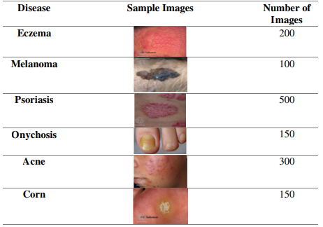

## *Classification Steps*

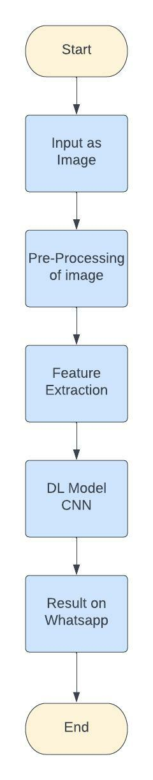

## *WhatsApp Bot*

The WhatsApp bot is really simple and easy to use. User have to open his/her whatsapp and then just put the image of the disease and will get and instant reply about the disease and its type. There will be description of the disease and its type if it is cancerous or not.

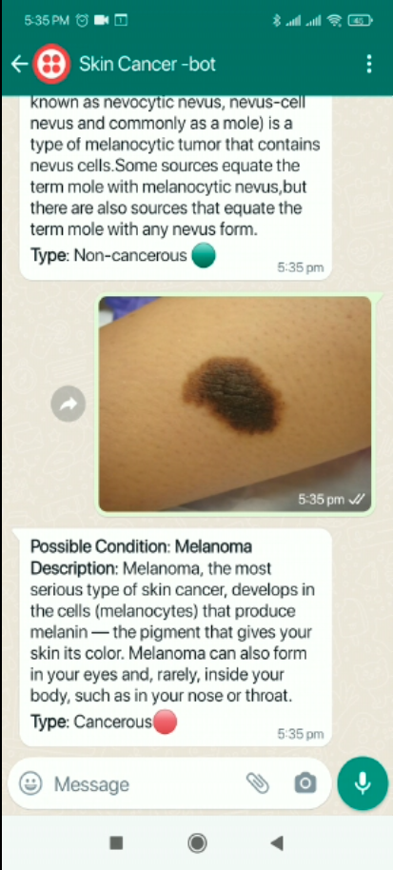

*D. Feature Extraction:*

The main characteristic extracted from an image is color. The color of the affected area of ​​disease helps to identify the type of disease. The image is binarized and then skin colors are extracted using the YCbCr algorithm. Skin detection depends on the pixel and the RGB color ratio of each pixel. A YCbCr value may be generated from the RGB ratio for each pixel. And is put into a formula. Y = 0.3R+0.29G+0.10B Cr = R – Y Cb = B – Y The true positive (TP) and True Negative (TN) are checked based on the total number of pixel and then using the algorithm to find the TP and TN. Precision: TP/(TP+FP) Accuracy: TP + TN/ (TP+TN+FP+FN) FP: False Positive FN: False Negative The next feature which we extracted is the size of the infected area. The binary image is converted into a histogram and then the pixels of the histogram are multiplied by the whole area to find out the total area of infection. Identification of the size of the infected area helped our model to ease the prediction of our classifier to find the disease. To train our model, we need to train a feedforward backpropagation neural network to execute our description word . Extraction of various features from one of the images of one of more than known diseases, psoriasis. Contrast Min: 8.7 Max: 41.256, Correlation Min: 1.8612 Max: 3.6759, Entropy Min: 0.1879 Max: 0.613, Uniformity Min: 3

# Results And Observations

To optimize the skin image initially, we apply some image processing techniques by removing the background. Therefore, a histogram is created to identify the damaged areas and the intensity of the image is adjusted using the appropriate cavity histogram equalization technique. increase the contrast. Contrast does not always need to be increased. Histogram equalizationcan be worse in some cases. In this case, by reducing the contrast and plotting the skin colors, you can tell which skin is infected and which is not.

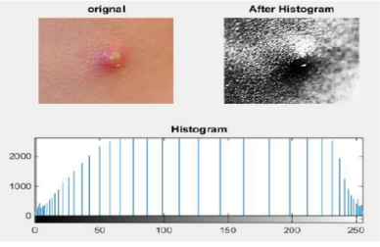

Results are based on pre-trained models and minor modifications. Images are loaded into the model, resulting in disease detection rates. All six types of disease have different detection rates and may vary depending on the nature of the image.

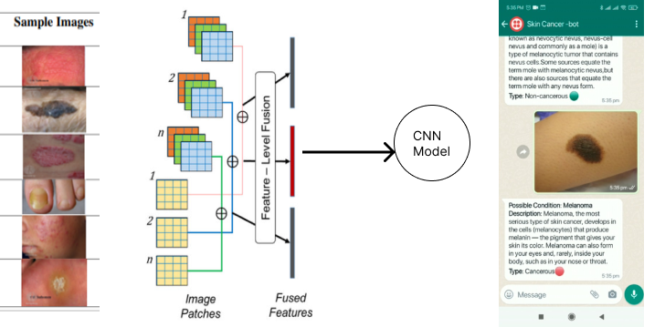

Disease detection can help reduce the problem of spreading skin diseases, and will provide the best way to identify skin problems. This will allow you to handle the at a low cost without delay. In addition, most skin diseases are easily transmitted by touch, which will aid in early detection and early treatment before the disease spreads. In our application, we used a modified pre-trained convolutional neural network model. This will help diagnose skin diseases

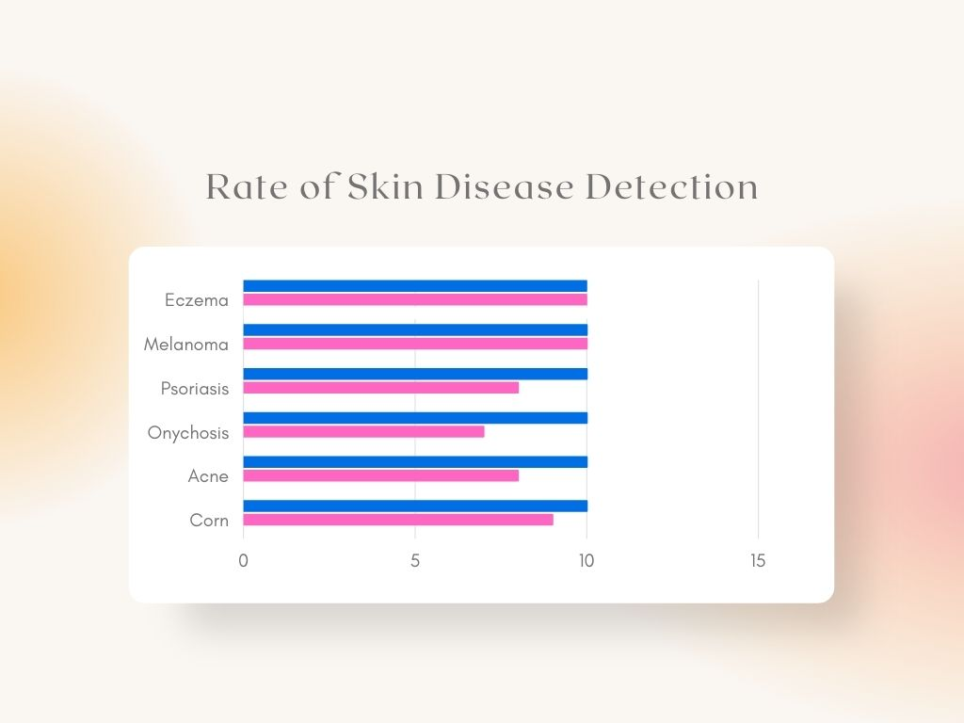

in rural India where basic medical facilities are already severely lacking.

# Conclusion

There is a need to incorporate clinicians in the design process for these algorithms and a need to build intrinsically explainable deep learning algorithms for cancer detection. It is important to evaluate proposed methods alongside clinicians to determine the clinical strengths and weaknesses of the methods As per the Covid rules and guidelines there is need of these new methods to be introduced. This article used Deep Learning Studio and Model-Driven architecture for deep learning. This article introduces the capabilities of the DLS tool and shows the process of building a deep learning model using it. This paper describes the data preparation process using dermal cell imaging and the application of the test in a DLS model for cancer cell detection. The DLS model achieved an AUC of 99.77% when detecting cancer cells in cancer cell images. This document represents a possibility for programmers to obtain the model's program code for further study. Loading trained models and enabling the ability to develop enterprise-grade applications is the best baseline exploration for future work in this article. Finally, the article achieved the goal of the introductory part.

The past few decades have witnessed a revolution in the detection and cure of cancer using machine assistance. Accordingly, this paper has presented a systematic review of current techniques in the diagnosis and cure of several cancers affecting the human body badly. The focus of this article is to review, analyze, and categorize methodologies of different types of cancer and uncover existing limitations. The review has presented six types of cancers lung cancer, breast cancer, brain tumor, liver cancer, leukemia, and skin cancer. Additionally, this study has presented four significant stages of automated cancer diagnosis such as image preprocessing, tumor segmentation, feature extraction, and classification using benchmark datasets. The main purpose of this study is to provide an intellectual background for new researchers who want to start research activities in this field.

This article used Deep Learning Studio, a model-based architecture for deep learning. This article introduces the capabilities of the DLS tool and shows the process of building a deep learning model using it. This paper describes the data preparation process using dermal cell imaging and the application of the test in a DLS model for cancer cell detection. The DLS model achieved an AUC of 99.77% when detecting cancer cells in cancer cell images.This article used Deep Learning Studio and ModelDriven architecture for deep learning. This article introduces the capabilities of the DLS tool and shows the process of building a deep learning model using it. This paper describes the data preparation process using dermal cell imaging and the application of the test in a DLS model for cancer cell detection. The DLS model achieved an AUC of 99.77% when detecting cancer cells in cancer cell images.

##### References

1. [1] Arifin, S., Kibria, G., Firoze, A., Amini, A., & Yan, H. (2012) “Dermatological Disease Diagnosis Using Color-Skin Images.” Xian: International Conference on Machine Learning and Cybernetics. W.-K. Chen, Linear Networks and Systems (Book style). Belmont, CA: Wadsworth, 1993, pp. 123–135.
2. Nawal Soliman ALKolifi ALEnezi “A method of skin disease detection using image processing and machine learning” at 16TH International learning & Technology conference 2019
3. Pravin S. Ambed, A S Shirsat “A image analysis system to detect skin diseases” at IOSR Journal of VLSI and signal processing Volume 6 Issue 5 Ver 1 e-ISSN 2013-4200
4. Li-Sheng Wei, Quan Gan and Tao ji “Skin Disease Recognition Method Based on Image Color and texture features”Y. Computational and Mathematical Methods in Medicine Volume 2018, Article ID 8145713, 10 pages https://doi.org/10.1155/2018/8145713
5. R. Sumithra, M. Suhilb, and D. S. Guruc, “Segmentation and classification of skin lesions for disease diagnosis,” Procedia Computer Science, vol. 45, pp. 76–85, 2015.
6. Rahat Yasir, Md Ashiqur rehman and Nova Ahmed “Dermatological Disease Detection using image processing and Artificial Neural Network” 8th International Conference on Electrical and Computer Engineering 20-22 December, 2014, Dhaka, Bangladesh
7. R. Yasir, M. S. I. Nibir, and N. Ahmed, “A skin disease detection system for financially unstable people in developing countries,” Global Science and Technology Journal, vol. 3, no. 1, pp. 77–93, 2015.
8. Kumar, V., Kumar, S., & Saboo, V. (2016) “Dermatological Disease Detection Using Image Processing and Machine Learning.” IEEE.
9. S. Kumar and A. Singh, “Image processing for recognition of skin diseases,” International Journal of Computer Applications, vol. 149, no. 3, pp. 37–40, 2016.
10. Dawid Połap,* Alicja Winnicka, Kalina Serwata, Karolina Kęsik, and Marcin Woźniak et al. An Intelligent System for Monitoring Skin diseases. Published online 4 August 2018, DOI: 10.3390/s18082552
11. Z. Hu and C. S. Yu, “Functional research and development of skin barrier”, Chinese Journal of clinicians, vol. 7, no. 7, pp. 3101-3103,2013
12. Nidhal K. Al Abbadi, Nizar Saadi Dahir, Muhsin A. AL-Dhalimi and Hind Restom, ''Psoriasis Detection Using Skin Colour and Texture Features'', Journal of Computer Science 6 (6): 626- 630, 2010, ISSN 1549-3636, © 2010 Science Publications
13. Megha D. Tijare, Dr. V. T. Gaikwad at el. “Detecting skin disease by accurate skin segmentation using various color spaces” Published 2018 in Journal of Engineering Research and application.
14. Ekta Singhal, Skin Cancer Detection using Artificial Neural Network, International Journal of Advanced Research in Computer Science Volume 6, No. 1, Jan-Feb 2015.
15. Manish Kumar and Rajiv Kumar, An intelligent system to diagnosis the skin disease, ARPN Journal of Engineering and Applied Sciences VOL. 11, NO. 19, OCTOBER 2016 ISSN 1819-6608.
16. Shashi Rekha G, Prof. H. Srinivasa Murthy, Dr. Suderson Jena et al. “Digital Dermatology – skin Disease Detection Model Using Image Processing. Published in International Journal of Innovative Research in Science, Engineering and Technology. Vol 7, Issue 7, July 2018.
17. Balaji, V. R., Suganthi, S. T., Rajadevi, R., Kumar, V. K., Balaji, B. S., & Pandiyan, S. (2020). Skin disease detection and segmentation using dynamic graph cut algorithm and classification through Naive Bayes Classifier. Measurement, 107922.
18. ALEnezi, N. S. A. (2019). A Method Of Skin Disease Detection Using Image Processing And Machine Learning. Procedia Computer Science, 163, 85-92.
19. Sumithra Ra, Mohammad Suhilb, D.S.Guruc, Segmentation and Classification of Skin Lesions for Disease Diagnosis, (ICACTA-2015) International Conference on Advanced Computing Technologies and Applications
20. S. Menzies, C. Ingvar, K. Crotty and W. McCarthy. 1996. Frequency and morphologic characteristics of invasive melanomas lacking specific surface microscopic features. Arch. Dermatol. 132(10): 1178- 1182.
21. Kolkur, S., & Kalbande, D. R. (2016, November). Survey of texture based feature extraction for skin disease detection. In 2016 International Conference on ICT in Business Industry & Government (ICTBIG) (pp. 1-6). IEEE.
22. Chakraborty, S., Mali, K., Chatterjee, S., Banerjee, S., Mazumdar, K. G., Debnath, M., ... & Roy, K. (2017, August). Detection of skin disease using metaheuristic supported artificial neural networks. In 2017 8th Annual Industrial Automation and Electromechanical Engineering Conference (IEMECON) (pp. 224-229). IEEE.
23. Pugazhenthi, V., Naik, S., Joshi, A., Manerkar, S., Nagvekar, V., Naik, K., ... & Sagar, K. (2019). Skin Disease Detection And Classification.
24. Aziz, A., Hartono, R., & Abdilah, R. (2020, June). Decision Support System for Detection of Skin Diseases in Smart Health development planning. In IOP Conference Series: Materials Science and Engineering (Vol. 858, No. 1, p. 012051). IOP Publishing.
25. Kumar, N & Kumar, P & Pramodh, K & Karuna, Yepuganti. (2019). Classification of Skin diseases using Image processing and SVM. 1-5. 10.1109/ViTECoN.2019.8899449.
26. H. Guo and H. T. Huo, “Research on the application of gray level co-occurrence matrix for skin texture detection,” Journal of Image and Graphic, vol. 15, no. 7, pp. 1074–1078, 2010.
27. S. De, R. Joe Stanley, C. Lu et al., “A fusion-based approach for uterine cervical cancer histology image classification,” Computerized Medical Imaging and Graphics, vol. 37, no. 8, pp. 475–487, 2013.
28. A. Masood, A.A. Al-Jumaily Review article computer aided diagnostic support system for skin cancer: a review of techniques and algorithms
29. R. Siegel, D. Naishadham, A. Jamal Cancer statistics, 2012 Cancer J. Clin. (2012), pp. 10-29, 10.3322/caac.20138
30. R. Siegel, K.D. Miller, A. Jamal Cancer statistics, 2018 Cancer J. Clin. (2018), pp. 7-30, 10.3322/caac.21442
31. A. Esteva1, B. Kuprel1, R.A. Novoa, J. Ko, S.M. Swetter, H.M. Blau, S. Thrun Dermatologist-level classification of skin cancer with deep neural networks Nature (2017), pp. 115-126, 10.1038/nature21056
32. H. Kittler, H. Pehamberger, K. Wolf, M.J.T.I.O. Binder Diagnostic accuracy of dermoscopy Clin Dermatol (2002), pp. 159-165, 10.1046/j.1365-2230.2000.00693.x
33. M.M.M. Zorman, S.P. Kokol, I. Malcic The limitations of decision trees and automatic learning in real world medical decision making J Med Syst (1997), pp. 403-415
34. D Ruiz, V Berenguer, A Soriano, B Sanchez A decision support system for the diagnosis of melanoma: a comparative approach Expert Syst Appl, 38 (12) (Nov-Dec 2011), pp. 15217-15223 Yuan Cao, Qin Gao, Klaus Macherey, et al. Google’s neural machine translation system: Bridging the gap between human and machine translation. arXiv preprint arXiv:1609.08144, 2016.